Working instructions (Betriebsanweisung) „Coronavirus“ for the time of reduced operation
Department / institution etc. |  | Place of work/occuptation:
Approved by (Date, signature): |  | Date: 5.5.2020

SCOPE OF APPLICATION
Activities involving physical contact with other persons (colleagues, students and visitors)
Protection goal: Avoid infections and interrupt chains of infection!

Threats for PersONS
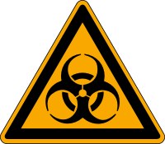 | The "Coronavirus Disease 2019 (COVID-19)" is caused by the coronavirus SARS-CoV-2  - Transmission route: The virus is mainly transmitted by droplets moving through the air. A smear infection via contaminated hands to mucous membranes (mouth, nose, eye) is also possible.  - Incubation period: After an infection it can take a few days to two weeks before signs of the infection appear. Even without symptoms the disease can be transmitted.  - Health effects: Infections are usually mild and asymptomatic. Acute symptoms of the disease can also occur, e.g. respiratory diseases with fever, cough, shortness of breath and breathing difficulties. Particularly in persons with previous illnesses or whose immune system is weakened, the course of the disease can be severe to fatal.

protective measures and rules of conduct
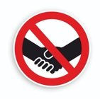  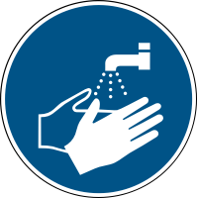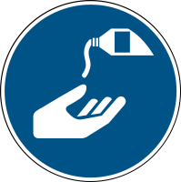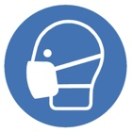 | To reduce the risk of infection, the following protective measures and rules of conduct must be observed  Avoid direct physical contact  - Do not shake hands and avoid other physical contact  - Keep at least a distance of 1.5 m to other persons  - Reduce the number of people in the same room at the same time  - Work from home or work in an individual office  - Use confined spaces (e.g. lifts, sanitary facilities, changing rooms, showers, photocopying rooms, tea kitchens) only by one person at the same time  Personal hygiene measures  - If you need to cough or sneeze, use a tissue or the crook of your arm – if you use a tissue, make sure you dispose your used tissue in a bin with a lid  - Keep your hands away from your face – avoid touching your mouth, eyes or nose with your hands  - Wash your hands regularly and properly (at least 20 seconds) with liquid soap, use disposable towels  Technical and organisational measures  - Ventilate rooms regularly / leave technical room ventilation switched on.  - Provide plexiglass shields between persons if the minimum distances of 1.5 m cannot be kept  - Coordinate work and break times in your team  - If possible, use tools individually and clean them regularly.  - Personal protective equipment and work is for individual use  - All personal protective equipment and work wear is for individual use only. Clean work wear regulary.  Personal protection measures  - - If the safety distance cannot be kept, a face mask should be worn
First Aid
- In case of symptoms, contact your family doctor, discuss further measures, inform your superiors
- Members of the RUB with COV-19 symptoms are not allowed to enter the premises
- COVID-19 patients and contact persons must follow the quarantine orders of the health authority in charge (Gesundheitsamt)
- Note special measures for the provision of first aid. https://www.dguv.de/fb-erstehilfe/nachrichten/meldungen2020/faqs-erste-hilfe/index.jsp
WASTE MANAGEMT
 | - Dispose dirty or items no longer needed. The waste disposal regulations of the university apply.
Beratung
- For advice re. medical matters contact the universitiy’s company physician, email:
- Occupational health and safety specialists are also available for consultation, email:

